State of Louisiana

Louisiana State Board

Of

Home Inspectors

Board Members

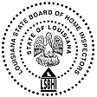

John Bel Edwards
Governor

Fredrick Williams

CHAIRMAN
District 1 – William Paternoster District 2 – David Holt District 3 – Paul Brunet District 4 – Fredrick Williams
District 5– Robert Smith District 6 – John McLaughlin At Large –Jean Picou Jr.

October 31, 2023

VIA EMAIL

RE: LSBHI Pre-licensing Education RENEWAL

Dear Education Provider,

This letter is to confirm that the Louisiana State Board of Home Inspectors has received and processed your annual renewal as a Board-approved Pre-Licensing Education Renewal Application.

Your next application for renewal will be due December 2024. We thank you for your application and look forward to working with you.

Please take a minute to review your listing on our website www.inspectlouisianahomes.com . If any changes need to be made, please email them to LSBHI@lsbhi.la.gov.

If you have any questions or concerns, please do not hesitate to call me at 225-248-1334.

Sincerely,

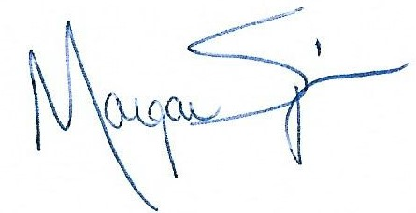

Morgan D’Amores Spinosa
Chief Operating Officer
Louisiana State Board of Home Inspectors

